**Page Flows**

1. User Registration / Log In

When users open the app for the first time, they are required to create an account to log in. Users provide a username and password, then link the app with Leetcode (password of Leetcode will only be stored locally, not in the server’s database).

If an account has already been logged in on this device, the app will remember the account. But if the user would like to switch accounts there is a log in page for him to log in again.

2. Main Page - Starting a task

The central page is for starting a concentration task and viewing current Leetcode progress. Main page has a big ‘START’ button and once clicked there is no way back until the user is able to finish the Leetcode progress and the system verifies this. After hitting the start button user will be directed to the task page.

3. Task Page – When In Progress

When the user starts a Leetcode task this page will display his current status like time spent and acceptance / submission progress. There is a big ‘VERIFY TASK’ button and when clicked the system will grab data from Leetcode website using user’s account and verify if the acceptance number is enough. Only when verified the page can exit and Facebook is no longer blocked.

4. Settings and Information

From both Main page and Task page the user can access ‘Settings’ by clicking on the left top corner of the app. The settings include multiple pages in which detailed configuration is allowed, like number of problems to be solved each time, websites to be blocked, etc.

Also there’s an information or help page providing necessary specification and guidance for the application.

5. Pick-One

The pick-one-problem page displays a new Leetcode problem when user shakes the phone. It’s an interesting feature when the user wants to get started but has no idea what to begin with. This page can be accessed via the main page.

Page Flow Diagrams:

Homepage

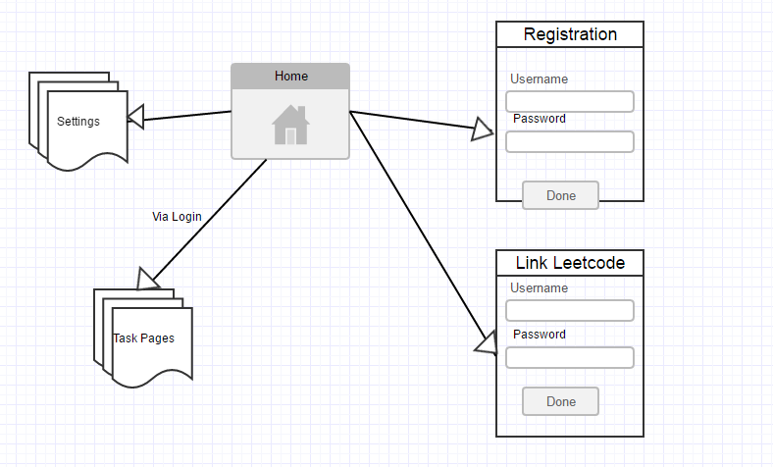

Main Page

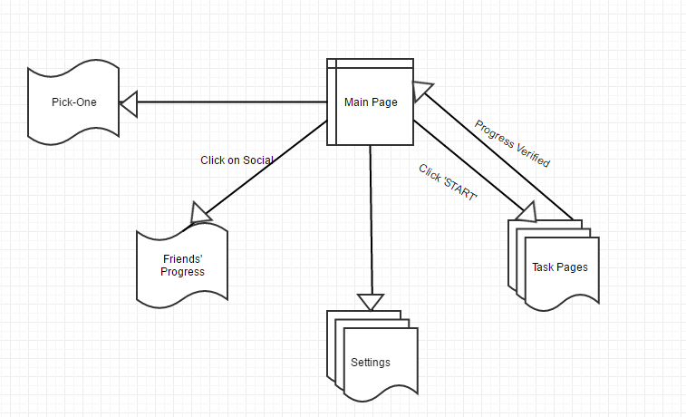

Task Page

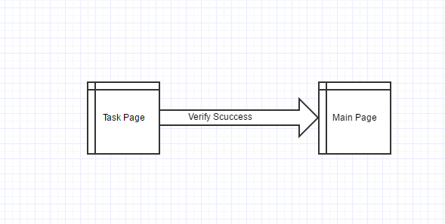

Settings and Information

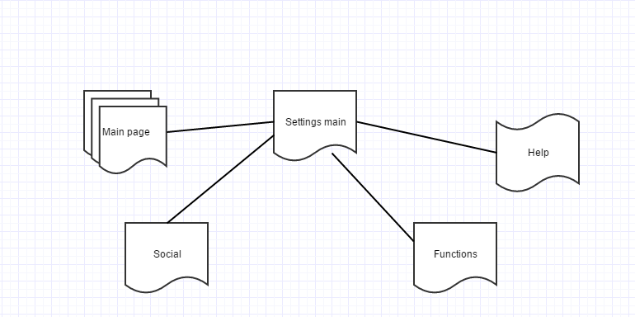

Pick-One-Problem

